**Design Thinking**

1. **What is Design Thinking?**

Design Thinking is a human-centered approach to innovation that draws from the designer’s toolkit to integrate the needs of people, the possibilities of technology, and the requirements for business success.

1. **What are the key features of Design Thinking?**

* A creative problem-solving strategy prioritizing customer requirements.
* Involves experimentation, prototyping, customer feedback, and redesigning.
* Applicable to fields like architecture, engineering, and business.
* A solution-based approach focusing on solving problems instead of identifying obstacles.

1. **How does Design Thinking differ from problem-based thinking?**  
   Design Thinking focuses on finding solutions, whereas problem-based thinking focuses on identifying obstacles and limitations.
2. **Who proposed the four principles of Design Thinking?**  
   Christoph Meinel and Larry Leifer.
3. **What are the four universal principles of Design Thinking proposed by Christoph Meinel and Larry Leifer?**

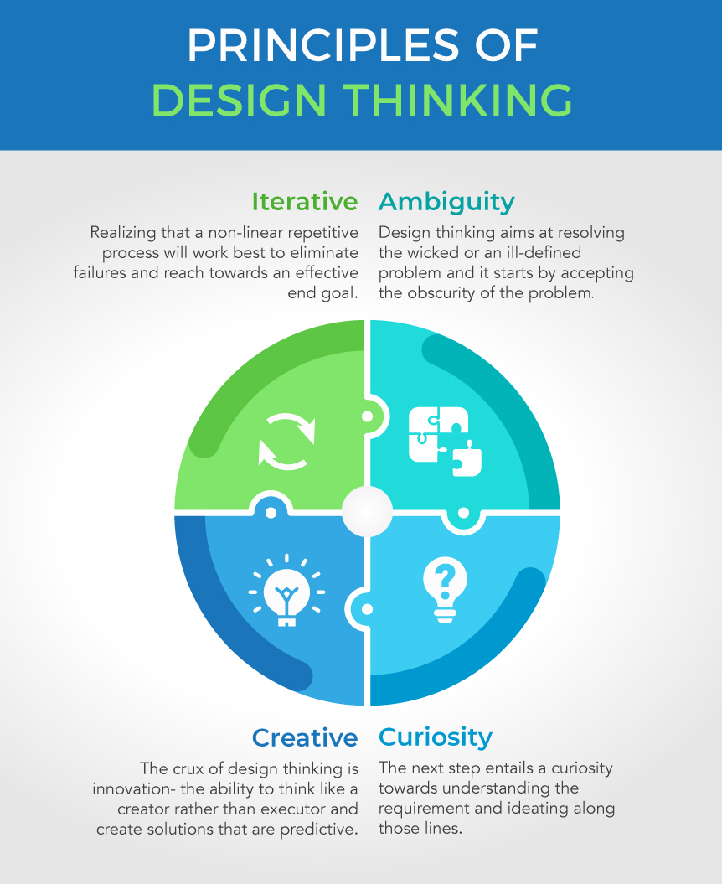

1. **What are the five phases of Design Thinking proposed by the Hasso-Plattner Institute at Stanford?**

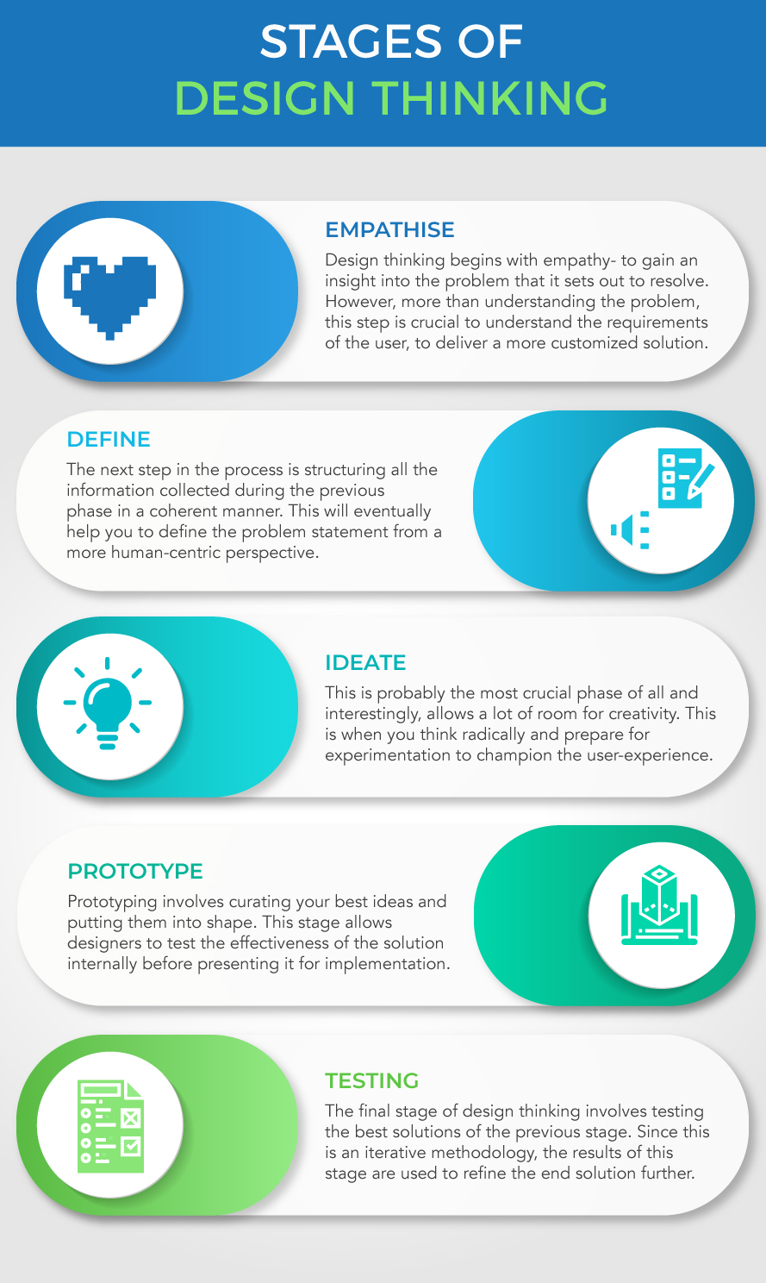

1. **Where can Design Thinking be applied?**

Design Thinking can be applied in various fields including business, information technology, education, and healthcare.

* **Business**: It helps in optimizing processes related to product creation, marketing, and contract renewal by focusing on customer needs.
* **Information Technology**: It aids in empathizing with users and solving their problems through brainstorming and innovative solutions.
* **Education**: It helps in creating solutions based on student feedback to address classroom challenges and improve engagement.
* **Healthcare**: It addresses inefficiencies and challenges in the healthcare system to provide quality care at lower costs.

1. **Hawkers and pedestrians perception emphasize.**

When discussing the perception of hawkers and pedestrians, the key emphasis is often on the potential conflict between the space occupied by street vendors (hawkers) and the movement of pedestrians, leading to concerns about congestion, safety.

* **Negative perceptions of hawkers:**
  + **Obstruction:** Pedestrians often perceive hawkers as blocking pathways, creating congestion, and hindering their movement freely.
  + **Hygiene concerns:** In some cases, unhygienic practices by hawkers can lead to negative perceptions from pedestrians regarding food safety.
  + **Legality issues:** Depending on local regulations, hawkers may be seen as operating illegally, further contributing to negative perceptions.
* **Positive perceptions of hawkers:**
  + **Affordability:** Many pedestrians appreciate the accessibility and affordability of food and goods offered by street vendors.
  + **Cultural vibrancy:** Street markets with hawkers can be seen as a key part of a city's cultural identity and character.
  + **Community support:** Local communities often rely on street vendors for essential items and services.

1. **What is the definition of empathy?**  
   Empathy is the ability to emotionally understand what others feel, see things from their perspective, and imagine oneself in their place.
2. **How does Merriam-Webster define empathy?**

Merriam-Webster defines empathy as "the action of understanding, being aware of, being sensitive to, and vicariously experiencing the feelings, thoughts, and experience of another."

1. **What are some common signs of empathy?**

* Being a good listener.
* Offering advice and support.
* Picking up on others' emotions.
* Feeling overwhelmed by tragic events.
* Caring deeply for others.
* Struggling to set boundaries in relationships.

1. **What are the three types of empathy?**

The three types of empathy are:

* **Affective empathy:** Understanding another person's emotions and responding appropriately.
* **Somatic empathy:** Having a physical reaction in response to what someone else is experiencing.
* **Cognitive empathy:** Understanding another person's mental state and what they might be thinking.

1. **How is empathy different from sympathy and compassion?**

Empathy involves an active attempt to understand another person, while sympathy and compassion are often more passive connections.

1. **How does empathy differ from sympathy and compassion?**

Here’s a brief summary of the differences between empathy, sympathy, and compassion:

* **Empathy**: Involves understanding and sharing another person’s feelings by putting yourself in their shoes.
* **Sympathy**: Involves feeling sorry or pity for someone else’s suffering, but without necessarily understanding their emotions deeply.
* **Compassion**: Involves recognizing someone’s suffering and feeling motivated to help alleviate it.

1. **What are the benefits of empathy?**

* **Building social connections:** By understanding what people  are thinking and feeling, you are able to respond appropriately in social situations.
* **Regulating emotions:** Emotional  regulation is important in that it allows you to manage what you are feeling, even in times  of great stress, without becoming overwhelmed.
* **Promoting helpful behaviors:** Not only are you more likely to engage in helpful  behaviors when you feel  empathy for other people, but other people are also more likely  to help you when they experience empathy.

1. **What are the challenges or pitfalls of empathy?**

* Empathy fatigue (emotional exhaustion from overexposure to others' emotions).
* Increased risk of emotional negativity.
* Possible impact on judgment.

1. **What are the potential pitfalls of having too much empathy?**

Having too much empathy can indeed have some downsides:

* **Emotional Exhaustion:** Constantly feeling others’ emotions can lead to burnout and emotional fatigue.
* **Impaired Judgment:** Excessive empathy can cloud your decision-making, leading to enabling harmful behaviors.
* **Bias and Inequity:** Empathy can be biased, making it harder to empathize with those who are different from us.
* **Mental Health Issues:** Over-empathizing can contribute to anxiety, depression, and stress.

1. **What role does empathy play in relationships?**

Empathy can reduce conflict and increase warmth in sibling relationships and enhance forgiveness in romantic relationships.

1. **What are the barriers to empathy?**

* **Cognitive biases:** Sometimes the way people perceive the world around them is influenced by cognitive biases. For  example, people often attribute other people's failures  to internal characteristics, while blaming  their own shortcomings on external factors.
* **Dehumanization:** Many also fall victim to the trap of thinking that people who are different from them don't feel  and behave the same as they do.For example, when they watch reports of a disaster or conflict in a foreign land, people might be  less likely to feel empathy if they think that those who are suffering are fundamentally different  from themselves.
* **Victim-blaming:** Sometimes, when another person has suffered a terrible experience, people make the mistake  of blaming the victim for their circumstances. This is the reason that victims of crimes are often  asked what they might have done differently to prevent the crime.

1. **What are some explanations for empathy?**

* **Neuroscientific:** Brain regions like the anterior cingulate cortex and mirror neurons play a role.
* **Emotional:** Empathy allows individuals to share a wide range of emotional experiences.
* **Prosocial:** Empathy fosters altruism and social bonds, aiding survival and cooperation.

1. **Which brain region is critical for empathy?**

The inferior frontal gyrus (IFG) is essential for recognizing emotions and experiencing empathy.

1. **What did philosopher Adam Smith suggest about empathy?**

Adam Smith suggested that empathy allows us to experience things we might never otherwise fully feel.

1. **What did sociologist Herbert Spencer propose about empathy?**

Herbert Spencer proposed that empathy serves an adaptive function and aids in the survival of the species.

1. **What are personas?**

Personas are fictional characters created based on research to represent different user types. They help designers understand users’ needs, behaviors, and goals.

1. **Why persona is important in design?**

Importance in Design:

* **User-Centric Design**: Personas ensure that the design process is focused on real user needs and expectations.
* **Guiding Ideation**: They help in generating ideas and making design decisions that align with user goals.
* **Shared Understanding**: Personas provide a common reference for the design team, ensuring everyone is on the same page regarding user requirements.
* **Effective Evaluation**: They allow designers to evaluate and critique designs based on how well they meet the needs of the personas.

1. **At what stage of the design thinking process are personas typically created?**

Personas are usually created in the Define phase, synthesizing insights from the Empathize phase.

1. **What are the four types of personas?**

* **Goal-directed personas:** Focus on what the user wants to achieve with the product.
* **Role-based personas:** Centered around the user’s role in an organization or life.
* **Engaging personas:** Use stories and emotional insights to make personas relatable.
* **Fictional personas:** Created based on design team assumptions, not direct research.

1. **How do goal-directed personas differ from role-based personas?**

Goal-Directed Personas focus on what the user aims to achieve with the product or experience. They emphasize the user’s goals and motivations.

Role-Based Personas incorporate goal-directed information but also consider the user’s behavior and role within an organization. They are data-driven and use both qualitative and quantitative information.

Both types help in understanding user needs, but role-based personas provide a more comprehensive view by including the user’s role and behavior.

1. **What are the benefits of using engaging personas in the design process?**

Using engaging personas in the design process offers several benefits:

* **Enhanced Empathy**: Personas help designers understand and empathize with users’ needs, behaviors, and goals, leading to more user-centric designs.
* **Improved Focus**: They provide a clear focus on specific user goals, helping prioritize features and design decisions that align with user expectations.
* **Reduced Bias**: By representing real user data, personas help reduce cognitive biases, ensuring that design decisions are based on actual user needs rather than assumptions.
* **Better Communication**: Personas create a shared understanding among team members, facilitating better collaboration and decision-making throughout the design process.

1. **How can user personas improve business strategies and product development?**

User personas are powerful tools that can significantly enhance business strategies and product development. Here are some key benefits:

* **Enhanced Understanding**: Personas provide a deep understanding of user needs, behaviors, and pain points, allowing businesses to tailor their products and services more effectively.
* **Empathy and Connection**: By humanizing data, personas help teams empathize with users, fostering a stronger connection and ensuring that products resonate emotionally.
* **Informed Decision-Making**: Personas guide design and development decisions, ensuring that products align with user expectations and preferences.
* **Targeted Marketing**: Personas enable more precise marketing strategies by identifying the specific needs and desires of different user segments.

1. **What are some essential features of a user persona?**

* **Name:** To make the persona feel real.
* **Photo:** To visualize the persona.
* **Bio:** Background story.
* **Demographics:** Age, gender, location, etc.
* **Personality traits:** Cautious, impulsive, etc.
* **Motivations:** Reasons for using the product.
* **Goals and frustrations:** Related to the product or service.
* **Preferred brands and influences:** Insight into preferences.

1. **What is the define stage in Design Thinking?**

The define stage is the second step in the Design Thinking process, dedicated to defining the problem that the design will address.

1. **Why is the define stage crucial in the Design Thinking process?**

The Define stage is crucial in the Design Thinking process for several reasons:

* **Clarifies the Problem**: It helps to clearly articulate the problem you are trying to solve, ensuring that the team is aligned and focused on the right issues.
* **User-Centric Focus**: By defining the problem from the user’s perspective, it ensures that the solutions developed are relevant and address real user needs.
* **Guides Ideation**: A well-defined problem statement serves as a guide for brainstorming and generating innovative ideas in the next stages.
* **Sets the Foundation**: It lays the groundwork for the subsequent stages, making the process more efficient and effective.

1. **What is a problem statement in the context of Design Thinking?**

A problem statement identifies the gap between the current state and the desired state.

1. **What are the key elements of a good problem statement?**

Here are the key elements of a good problem statement:

* **Clarity**: Ensure the statement is easily understandable, free from jargon or technical complexities.
* **Relevance**: Tie the problem to the broader context, illustrating its impact and why it matters.
* **Specificity**: Clearly define the gap between the current state and the desired future state.
* **Impact**: Quantify the gap in terms of cost, time, quality, or other relevant metrics.

1. **What techniques can be used to create a meaningful problem statement?**

Creating a meaningful problem statement involves several key techniques:

* **Clarity**: Ensure the statement is easily understandable, free from jargon or technical complexities.
* **Specificity**: Clearly define the problem, avoiding vague or general descriptions.
* **Relevance**: Tie the problem to the broader context, illustrating its impact and why it matters.
* **Measurability**: Include criteria to assess the success or completion of the solution.

1. **What is ideation?**

Ideation is the third phase of the Design Thinking process focused on generating a broad range of ideas to address a defined problem.

1. **What is the main purpose of the ideation phase in Design Thinking?**

The ideation phase in Design Thinking is crucial for several reasons:

* **Generate Ideas**: It focuses on generating a broad set of ideas without judgment, encouraging creativity and innovation.
* **Challenge Assumptions**: Helps in questioning the obvious and exploring new angles and avenues.
* **Transition to Solutions**: Acts as a bridge between understanding user needs and developing potential solutions.
* **Foster Collaboration**: Encourages a collaborative environment where team members build on each other’s ideas.

1. **Why is it important to create a judgment-free zone during ideation sessions?**

Creating a judgment-free zone during ideation sessions is crucial for several reasons:

* **Encourages Creativity**: Participants feel free to share wild and unconventional ideas without fear of criticism, fostering innovation.
* **Increases Participation**: A supportive environment ensures everyone feels valued and willing to contribute, leading to a diverse range of ideas.
* **Enhances Collaboration**: Team members build on each other’s ideas, leading to more refined and effective solutions.
* **Promotes Open-Mindedness**: It helps challenge assumptions and explore new perspectives, essential for breakthrough solutions.

1. **How can changing the physical environment impact an ideation session?**

Changing the physical environment can significantly impact an ideation session in several ways:

* **New Stimuli**: A different setting introduces new stimuli, which can trigger fresh ways of thinking and help participants break out of their usual thought patterns.
* **Enhanced Creativity**: Moving away from the usual workspace can foster a more creative atmosphere, encouraging participants to think outside the box.
* **Improved Collaboration**: A new environment can level the playing field, making everyone feel more equal and open to sharing ideas.
* **Increased Focus**: Being in a dedicated space for brainstorming minimizes distractions, helping participants stay focused on the task at hand.

1. **What are some key ideation techniques mentioned in the document?**

Here are some key ideation techniques mentioned in the document:

* **Brainstorming**: Generating a large number of ideas in a short period, encouraging free thinking and creativity.
* **Mind Mapping**: Visualizing ideas and their connections to explore relationships and generate new concepts.
* **SCAMPER**: Using a checklist of prompts (Substitute, Combine, Adapt, Modify, Put to another use, Eliminate, Reverse) to innovate and improve ideas.
* **Role Playing**: Adopting different perspectives to understand problems and generate diverse solutions.

1. **How does the "How might we...?" methodology help in ideation?**

The “How Might We” (HMW) methodology is a powerful tool in the design thinking process. Here are some key points:

* **Reframes Problems**: HMW helps to reframe and open up problem statements, making them more actionable and less daunting.
* **Encourages Creativity**: By using the words “how,” “might,” and “we,” it fosters a collaborative and open-minded approach to ideation.
* **Bridges Define and Ideate Stages**: It serves as a bridge between defining the problem and generating ideas, ensuring that the ideation is focused and relevant.
* **Structured Approach**: The HMW formula provides a structured way to create effective questions that lead to innovative solutions.

1. **What is Doodling?**

Doodling refers to drawing, sketching, or scribbling idly, often when bored.

1. **What is the primary purpose of doodling?**

Doodling serves several important purposes:

* **Improves Memory and Focus**: Doodling can help improve memory retention and focus, especially during monotonous tasks.
* **Reduces Stress**: It can act as a stress reliever by lowering cortisol levels, making it easier to concentrate.
* **Enhances Creativity**: Doodling stimulates creative thinking and problem-solving by allowing the brain to explore new ideas.
* **Processes Information**: It helps in processing and understanding information by making abstract concepts more concrete.

1. **How does doodling affect cognitive processes in the brain?**

Doodling has several positive effects on cognitive processes:

* **Improved Memory**: Doodling can enhance memory retention by helping individuals recall more information, as it keeps the brain engaged and prevents it from wandering.
* **Enhanced Focus**: It helps maintain attention during monotonous tasks by providing just enough stimulation to keep the brain alert.
* **Stress Relief**: Doodling can reduce stress by lowering cortisol levels, which in turn improves focus and cognitive performance.
* **Creative Problem Solving**: It can aid in creative thinking and problem-solving by allowing the brain to process information in a relaxed state.

1. **What are the benefits of doodling for creativity and productivity?**

Doodling offers several benefits for creativity and productivity:

* **Enhances Memory**: Doodling can improve recall and help you retain information better.
* **Boosts Creativity**: It sparks new ideas and helps you think outside the box.
* **Reduces Stress**: Doodling can be a calming activity that reduces anxiety and stress.
* **Improves Focus**: It helps maintain attention and prevents the mind from wandering.

1. **How can doodling be integrated into design thinking?**

Integrating doodling into design thinking can be highly beneficial. Here are some key points:

* **Boosts Creativity**: Doodling helps in visualizing ideas and breaking mental blocks, making it easier to generate new concepts.
* **Enhances Focus**: It can improve concentration by keeping the mind engaged, especially during brainstorming sessions.
* **Facilitates Communication**: Doodles can serve as a universal language, helping to convey complex ideas quickly and effectively.
* **Encourages Reflection**: Reflective doodling allows designers to process and refine their thoughts, leading to better design outcomes.

1. **What is Storytelling?**

Designers use storytelling to get insight into users, build empathy and reach them emotionally.

1. **How can doodling be integrated into design thinking?**

Integrating doodling into design thinking can be highly beneficial. Here are some key points:

* **Boosts Creativity**: Doodling helps in visualizing ideas and breaking mental blocks, making it easier to generate new concepts.
* **Enhances Focus**: It can improve concentration by keeping the mind engaged, especially during brainstorming sessions.
* **Facilitates Communication**: Doodles can serve as a universal language, helping to convey complex ideas quickly and effectively.
* **Encourages Reflection**: Reflective doodling allows designers to process and refine their thoughts, leading to better design outcomes.

1. **How does conflict enhance user stories in design?**

Conflict plays a crucial role in enhancing user stories in design by:

* **Creating Engagement**: Conflict makes stories more engaging and relatable, helping users connect emotionally with the design.
* **Highlighting Problems**: It emphasizes the challenges users face, making it easier to identify and address their needs.
* **Driving Solutions**: By presenting obstacles, conflict encourages designers to think creatively and develop effective solutions.
* **Building Empathy**: Understanding user struggles fosters empathy, leading to more user-centric designs.

1. **What are the key elements of a good story according to Aristotle?**

Aristotle outlined six key elements of a good story in his work “Poetics”:

* **Plot**: The structure of events in the story, which should have a beginning, middle, and end, and follow a logical sequence.
* **Character**: The individuals who carry out the actions of the plot, whose personalities and decisions drive the story forward.
* **Thought**: The themes, messages, and ideas conveyed through the story.
* **Diction**: The choice of words and style of expression used in the dialogue and narration.
* **Melody** – How will the overall design pattern appear pleasant and predictable to  users, moving them emotionally?
* **Spectacle**: The visual elements of the story, including settings, costumes, and special effects.
* **Song**: The use of music and rhythm to enhance the emotional impact of the story.

1. **Why is Design Thinking important for organizations?**

Design Thinking is crucial for organizations due to several key reasons:

* **Human-Centric Approach**: It focuses on understanding and addressing the needs of users, leading to more effective and impactful solutions.
* **Innovation and Creativity**: By encouraging empathy and diverse perspectives, it helps teams overcome biases and generate innovative ideas.
* **Improved Collaboration**: It fosters a culture of collaboration and continuous improvement, making organizations more adaptable and resilient.
* **Efficiency and Speed**: Design Thinking can streamline processes, making organizations run faster and more efficiently.

1. **How can designers reach users through stories?**

Designers can reach users through stories by defining target users with personas, creating a plot with conflict, giving the design a supporting role, working with the setting, and tailoring the look and feel of the design.

1. **What is the importance of personas in storytelling for design?**

Personas are important in storytelling for design because they help envision users' likely experiences and gain empathic insights. They are based on user research and tell a story about the insights gained.

1. **What is prototyping?**

Prototyping is the process of transferring ideas and experiments from your head to the physical world.

1. **What are the advantages of prototyping a product?**

Prototyping allows for the application of an idea by understanding which aspects are hard or impossible to implement, helps test the usability of a site, presents ideas and concepts to users, reduces risks, improves on existing ideas, and simulates the final product.

1. **What are the two main categories of prototyping methods?**

The two main categories of prototyping methods are low-fidelity and high-fidelity prototyping.

Examples of low-fidelity prototypes include storyboarding, sketching, card sorting, and 'Wizard of Oz'.

1. **How does high-fidelity prototyping differ from low-fidelity?**

High-fidelity prototypes closely resemble the final product in appearance and functionality.

1. **What is a "Wizard of Oz" prototype?**

A method where functions are faked by designers to simulate a real experience for users.

1. **What are the benefits of prototyping?**

* By enabling designers to understand user needs and behaviors through interaction.
* It identifies and fixes errors early, reducing rework during the final stages.
* It highlights areas for improvement, making designs more user-centric.

1. **What are the benefits of feedback from prototypes?**

Feedback from prototypes provides a foundation for ideation, quick implementation of changes, helps understand where changes are needed, improves time-to-market, and gives insight into user requirements.

1. **What are key guidelines for effective prototyping?**

* **Just start building:**Creating a prototype will help  you to think about your  idea in a concrete manner, and potentially allow you to gain insights into  ways you can improve your idea.
* **Don’t spend too much time:**The longer you spend building your prototype,  the more  emotionally attached you can get with your idea, thus hampering  your ability to objectively judge  its merits.
* **Remember what you’re testing for:**Do not lose sight of that issue, but at the same  time, do not get so bound to it so as to lose sight of other lessons you could learn from.
* **Build with the user in mind:** Test the prototype against your expected user behaviours and user needs.

1. **Concept of Lego prototyping.**

Lego prototyping is a method of creating physical models of a product or design concept using Lego bricks. It can be a useful tool for product design.

1. **Discuss on guidelines of good prototyping.**

A good prototype should be focused on core functionalities, designed with user feedback in mind, iteratively developed, and should clearly define the product's key.

Key aspects of good prototyping:

* **Define clear objectives:**

Understand the specific questions you want to answer with the prototype, guiding the level of detail and functionality required.

* **Start with low-fidelity prototypes:**

Begin with simple sketches or wireframes to quickly test core concepts and user flows before investing in high-fidelity details.

* **Focus on user experience:**

Prioritize designing for intuitive interactions and user flows, ensuring the prototype accurately reflects how users will engage with the product.

* **Gather user feedback regularly:**

Conduct usability testing with representative users to identify pain points, areas of improvement, and validate design decisions.

* **Iterate and refine:**

Continuously improve the prototype based on feedback, making necessary adjustments to features and design elements.

* **Document your process:**

Keep track of design decisions, user feedback, and iterations to inform future development and decision-making.

1. **Pros and cons of high-fidelity prototyping.**

High-fidelity prototyping has many advantages, including:

* **Realistic preview**

High-fidelity prototypes closely resemble the final product, providing a realistic preview of the user experience.

* **Effective communication**

High-fidelity prototypes help communicate the final design vision to stakeholders and clients.

* **Accurate testing**

High-fidelity prototypes allow for accurate usability testing and user feedback.

* **Early-stage funding**

High-fidelity prototypes can help startups get early-stage funding.

However, high-fidelity prototyping also has some disadvantages, including:

* **Time-consuming**: High-fidelity prototypes can take a long time to create and make changes to.
* **Costly**: High-fidelity prototypes can be expensive to produce.
* **False impressions**: Users may mistake the prototype for the final product and form biases.
* **Scope creep**: If too much time is spent on details, the project can experience scope creep.

1. **Explain the eight common ways to prototype.**

* **Sketches and diagrams**: A simple form of prototyping that's often used in brainstorming sessions to communicate new ideas.
* **Paper Interfaces:** Paper interfaces are made using multiple sheets of paper  and sketching movable elements and interactive features on different sheets to create a more in depth look.
* **Storyboards:**Storyboarding is a great way of guiding people through a user  experience journey. Storyboarding is a technique derived from the film  industry and allows you a quick and cheap way of walking stakeholders and  users through a product.
* **Lego prototypes:**Lego prototyping is a method of creating physical models of a product or design concept using Lego bricks. It can be a useful tool for product design.
* **Role playing:**Also known as experiential prototyping, this method helps designers understand the user's experience of using a product or service.
* **Physical Models:**These are considered highfidelity prototypes. Physical modeis can be made out of a wide range of materials, such as paper, cardboard,  clay or foam and can be a range of sizes.
* **Wizard of Oz prototyping:**A faked prototyping method.
* **UserDriven Prototypes:**Now this one is a world apart from the others mentioned. Instead of building a prototype to test on users ‐ designers will ask users to create something within set constraints.

1. **What is a value proposition?**

A value proposition is a simple statement that summarizes why a customer would choose your product or service.

1. **Why is a value proposition important?**

A value proposition is important in design thinking because it helps businesses understand their customers' needs and deliver on their value in a more effective way.

* **Understand customers:** Design thinking helps businesses understand what their customers think their value proposition is, and how to better deliver on it.
* **Identify opportunities:** Design thinking can help businesses identify opportunities to redefine their value proposition.
* **Create a competitive edge:** A unique value proposition can help businesses attract new customers, investors, and clients, and build brand loyalty.
* **Validate demand:** Value proposition design and research can help businesses test their value propositions with potential customers to ensure there's demand for their product.
* **Optimize resources:** Research early on can help businesses make informed decisions about resource allocation.
* **Accelerate time-to-market:** Streamlined value proposition design and research processes can help businesses reduce time-to-market.

1. **What is the difference between a value proposition, mission statement, slogan, and tagline?**

* **Value Proposition:** Customizable performance or lifestyle sneakers with unique colorways and materials.
* **Mission Statement:** To bring inspiration and innovation to every athlete in the world.
* **Slogan:** Twice the guts. Double the glory.
* **Tagline:** Just do it.

1. **What are the steps to write a compelling value proposition?**

* Identify your customer's main problem.
* Identify all the benefits your product offers.
* Describe what makes these benefits valuable.
* Connect this value to your buyer's problem.
* Differentiate yourself as the preferred provider of this value.

1. **What makes a good value proposition?**

* **Customer-centric focus:** Prioritizing the user's needs and pain points above all else, ensuring the solution directly addresses their problems.
* **Empathy-driven insights:** Gaining a deep understanding of the user's context, motivations, and emotions through research and observation.
* **Clear problem definition:** Articulating the specific issue you are solving in a concise and actionable way.
* **Unique differentiation:** Highlighting what sets your solution apart from competitors, offering a distinct value proposition.
* **Measurable benefits:** Quantifying the positive impact your solution will have on the user, allowing them to understand the value clearly.
* **Iterative testing and refinement:** Continuously validating and improving your value proposition through user feedback and testing throughout the design process.

1. **Why is clear language important in a value proposition?**

It helps keep your value proposition clear and easy to understand, allowing your audience to quickly decide whether or not your product or service will be the best solution for them.

1. **What is Testing in Design Thinking?**

Testing is a crucial part of the design thinking process where UX teams usually test high-fidelity prototypes to validate the design.

1. **What happens during the Testing phase?**

The final solution of a product is tested on a full scale to evaluate whether it might work. The prototype considered best after feedback from customers and end-users is implemented. Testing can provide both positive and negative results and might lead to repeating the design thinking process if usability issues are found.

1. **How is User‐Testing conducted?**

In design thinking, user testing is conducted by creating a prototype of a solution, then observing and gathering feedback from representative users as they interact with it, allowing designers to identify usability issues, understand user needs better, and refine their design based on real-world feedback; this process typically involves recruiting participants, setting clear test objectives, creating tasks for users to complete, and carefully analyzing their actions and verbal feedback to identify areas for improvement.

* **Central to the process:**
  + User testing is considered the final stage of the design thinking process, where the developed prototype is tested with real users to validate its effectiveness.
* **Focus on observation:**
  + The primary method is to observe users interacting with the prototype, noting their behaviors, struggles, and positive experiences.
* **Recruiting relevant users:**
  + It's crucial to recruit participants who accurately represent the target user group to get meaningful feedback.
* **Structured tasks:**
  + Designers create specific tasks for users to complete during the test, allowing them to observe how users navigate through the prototype and identify potential pain points.
* **Qualitative and quantitative data:**
  + User testing gathers both qualitative feedback (user opinions, comments) and quantitative data (time taken to complete tasks, error rates).
* **Iterative process:**
  + Feedback from user testing is used to iterate and improve the design, often leading to multiple rounds of prototyping and testing.

1. **What are the challenges of a traditional product development approach?**

* **Sequential and gate-oriented process:**This step by step approach means tasks can’t move  unless the previous step is cleared.
* Handover between people leading to knowledge loss: There will be some knowledge loss as information is passed from  researchers to product developers.
* Risk of solving the wrong problem or developing the wrong product: Sometimes it can be a case  of developing the right product but solving the wrong issue.
* Long timeline with a tunnel effect:  In the sense that product development can drag on without  the end in sight.
* Generates a lot of waste: In short, this approach may not create the expected value for users and the company.

1. **How can a valuable product be delivered?**

By adopting a user-centric approach and keeping the user in mind at every step of the design process.

1. **What is the 4D Framework in design thinking?**

The 4D framework in design thinking is a structured but flexible process for creating customer-centric solutions. The 4D framework is also known as the Double Diamond model, and it consists of four stages:

* **Discover**: Focuses on the problem
* **Define**: Focuses on the problem
* **Develop**: Focuses on the solution
* **Deliver**: Focuses on the solution

The 4D framework is a holistic approach that ensures the final product is desirable, feasible, sustainable, and economically viable.

1. **What are the benefits of design thinking?**

* Without defining and researching your users, it is hard to understand their needs  and pain  points. This helps you to define the right problem to solve.
* When it comes to creating innovative solutions, it helps to define the product’s unique value  proposition before quickly evaluating solutions with prototyping and testing. This helps to  accelerate learnings and solutioning.
* The last and perhaps most important benefit of design thinking is the ability to engage your  users and co‐develop the product with them. Not only will users feel their concerns are being  heard, you will less likely waste time and resources developing a product, only to realize  you’ve been tackling the wrong problem.

1. **What gaps exist in design thinking?**

* Depending on the product team, there may be cases of creating unrealistic solutions that look nice  on paper or prototype, but are too expensive to develop into actual products.
* Design thinking usually ends at the prototyping phase so you may or may not have a final product  in the end.

1. **What is Agile design methodology?**

A software development methodology that helps organizations stay responsive to change by delivering software in increments.

1. **What are the main principles of Agile?**

* Focus on people doing the work and collaboration between business and IT.
* Seeking frequent feedback from end-users to iterate to the right outcomes.

1. **What are the four values of the Agile manifesto?**

* Individuals and interactions over processes and tools.
* Working software over comprehensive documentation.
* Customer collaboration over contract negotiation.
* Responding to change over following a plan.

1. **What are the benefits of Agile?**

* Ability to deliver early and often.
* Empowerment of the development team.
* Focus on business value.
* Increased product quality.
* Opportunities for improvements.
* Reduced waste.

1. **What gaps exist in Agile?**

* Developing the right product for the wrong problem.
* Over-reliance on the product owner's understanding and vision.

1. **How can design thinking and Agile be combined for end-to-end customer-centric product development?**

* **Empathize and Define Problem (Design Thinking):**
  + Start by utilizing design thinking's "empathize" and "define" phases to conduct thorough user research, identify pain points, and create detailed user personas, laying the foundation for a customer-centric problem statement.
* **Ideate and Prototype (Design Thinking):**
  + Brainstorm a wide range of potential solutions through design thinking's "ideate" phase, then rapidly prototype concepts to test and gather feedback early on.
* **Agile Sprints:**
  + Divide the development process into short, iterative "sprints" where the design prototypes are refined based on user feedback received during testing.
* **Continuous Feedback Loop:**
  + Incorporate regular user testing sessions throughout the development cycle to gather real-time insights and iterate on designs within each sprint.
* **Cross-Functional Teams:**
  + Assemble a diverse team including designers, developers, product managers, and user researchers to work collaboratively throughout the process, ensuring all perspectives are considered.
* **Prioritization:**
  + Use Agile frameworks like Scrum to prioritize features based on their value to the user and their alignment with the identified pain points.

1. **What are the steps in the simple and pragmatic approach of combining design thinking and Agile?**

* Start with stakeholder mapping, interviews, observations, and market research.
* Define the point of view through a problem statement and empathy map.
* Ideate on a value proposition canvas and customer journey.
* Prototype and test with a storyboard and digital prototype.
* Build purposefully with a product backlog and story mapping.
* Deliver incrementally.

1. **What are the advantages of using design thinking in software development?**

The advantages include:

* Solutions are prototyped.
* Results are verified.
* Best solutions are accepted.
* Solutions are experienced by the client before approval.
* Short iterations improve user experience.
* Small cross-functional teams.
* Incremental delivery is possible.
* Fast feedback helps designers and developers.
* Continuous improvement is possible.